Tony Twigg

**Fairweather, Ian (1891 - 1974)**

Ian Fairweather was a modernist painter who immigrated to Australia from Scotland. Unlike most European migrants to Australia, who sailed from the west across the Indian Ocean, Ian Fairweather came from the east, through Asia, on a journey that became the subject of his work and defined his contribution to Australian art. Central to Fairweather’s understanding of painting were periods spent working in Bali and China that introduced him to

a way of drawing radically different from the method he had studied at London’s Slade School. In Bali he worked at the edge of the cross-cultural art movement *Pita Maha,* fostered by Walter Spies. The movement introduced him to a meandering line which flowed around subjects and, in classical Kamasan-style painting, was highlighted with red. Fairweather adopted both mannerisms. In China he encountered calligraphy, an art he described as beautiful and austere; this became the rigorous mode of his own expression. Fairweather devised a landscape of humanity drawn from Asia that found a deep resonance in the Australian psyche.

After his initial art studies and following his service in WWI, Fairweather travelled west through Canada to reach Shanghai, where he spent four years working as a civil servant. In 1933, he decided to become an artist and travelled to Bali. It was the beginning of an odyssey that, with Fairweather intermittently travelling and painting in the Philippines, China, Australia and India, would irrevocably lead him to Australia.

Fairweather came to Australia four times. In 1934 he briefly visited Melbourne. While his work floundered, Jock Frater introduced him to a circle of modernist artists who drew him into Australia’s artistic life. He went to Queensland in 1938, working at Sandgate and Malay Town near Cains before serving in WWII. Returning in 1943, he stayed until 1952, when he was driven to “escape” on a raft. In 1953, at sixty-two, he settled on Bribi Island, where he found serenity and made a body of work that identified him as Australia’s most influential abstract artist of the mid-20th century.

In *Anak Bayan* (1957) Fairweather painted a cubist-influenced depiction of the procession of a religious sculpture known as Black Nazarene, as it took place during Holy Week in Manilla in the 1930s, when he lived there. The title is Filipino slang meaning “native”, and the painting is peppered with observations of the procession. We see the bare feet of Nazarene devotees, a boy carrying a candle with a sweat-protecting towel tucked into his shirt collar, the peasant Madonna, and a man prostrating himself along the bottom of the painting.

Commenting further on the distinction between European and Asian art, Fairweather observed, “You see, the portrait painter must subdue his own personality…to that of the sitter…I like the Chinese resent this…The individual is not as important, fundamentally, as the whole human structure.”

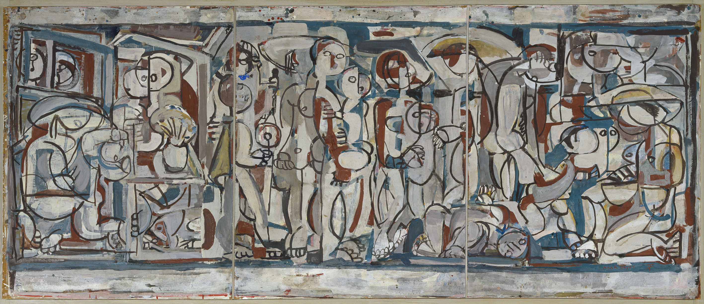

*Anak Bayan,* 1957, gouache on cardboard on hardboard, 96.8 x 227.3 Collection of the Art Gallery of New South Wales. Copyright held by the estate of Ian Fairweather see Viscopy and Dacs (UK)

**References and further reading**

Abbott-Smith, M. (1978) *Portrait of an artist Ian Fairweather*, Brisbane: University of Queensland Press

Bail, M. (2008) *Fairweather*. Sydney: Murdock Books. (This is a revised edition of the principal monograph that was first published in 1981).

Fisher, T. (1998) *The drawings of Ian Fairweather.* Canberra: National Gallery of Australia. (An exhibition catalogue that surveys the artist’s central practise, drawing).